**Algorithm for the problems**

**O(n2)**

* READ, how many number of values user want, n
* LET i=0
* WHILE i<n
  + READ value, v[i++]
  + END WHILE
* LET i=0, min=val[0]
* WHILE i<n
  + LET k=i
  + WHILE k<n
    - IF val[i]<val[j] THEN
      * IF val[i]<min THEN
        + LET min = v[i]
        + END IF
      * END IF
    - LET j++
    - END WHILE
  + LET i++
  + END WHILE
* PRINT minimum value is
* PRINT min

Program written given below

void on2()

{

int k,n,l,min;

int v[100];

printf("How many value do you want?");

scanf("%d",&n);

printf("enter the value");

for(k=0;k<n;k++)

{

scanf("%d",&v[k]);

}

min=v[0];

for(k=0;k<n;k++)

for(l=k+1;l<n;l++)

if(v[k]<v[l])

if(v[k]<min)

min=v[k];

printf("the minimum value is %d",min);

}

Hence, the T(n)=1+n+1+n2

Or T(n)=n2+n+2

Therefore, O(n2)

Output is

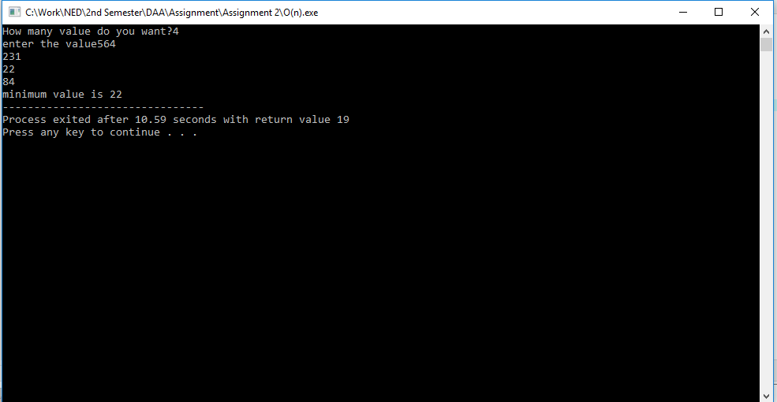

**O(n)**

* READ, how many number of values user want, n
* LET k=0
* WHILE k<n
  + READ value, val[i++]
  + END WHILE
* LET k=1, m=val[0]
* WHILE k<n
  + IF v[k]<min THEN
    - LET min = v[k]
    - END IF
  + END WHILE
* PRINT minimum value is
* PRINT min

Program written is given below

void on()

{

int k,l,min,v[100];

printf("How many values do you want?");

scanf("%d",&n);

printf("enter the values");

for(k=0;k<n;k++)

{

scanf("%d",&v[k]);

}

min=v[0];

for(k=1;k<n;k++)

{

if(v[k]<min)

min=v[k];

}

printf("minimum value is %d",min);

}

Hence, the T(n)=1+n+1+n

Or T(n)=2n+2

Therefore, O(n)

Output is given below

